Reception Learning 18th November- 22nd November 2024

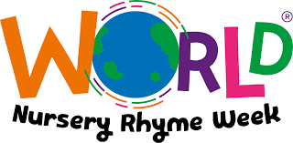**English**

In English we will be celebrating nursery rhyme week! We will be talking about and singing our favourite nursery rhymes. We will also be building and writing about our own farms- linking to Old Macdonald had a Farm.



**Phonics**

We will be learning the sounds g, o , c, k. We will learn the high frequency words: on, not, do, to, no, go, so, into, can.

**Topic**

In science we will be exploring the moon. We will talk about when we see the moon and what it looks like. We will then be making our own moon craters by throwing rocks into flour.



In history we will be learning about famous astronauts Neil Armstrong and Mae Jamison.

In PE we will start our gymnastics unit by pretending to be animals and moving our bodies in lots of different way.

**Maths**

In maths we will be representing the number 5 in lots of different ways including fingers, tens frames, dice frames, multilink and many more. We will encourage the stem sentence ‘I have 5 fingers on my hand’ and ‘There are 5 spaces on a dice frame’

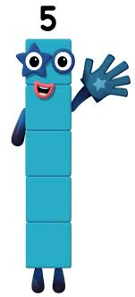

**Other points**

**Christmas Nativity:** 9th December 2024 starting at 2pm entering via the community door

Please make sure reading journals are signed and returned to us. We encourage that you read with your child every day.

Thank you for your continued support.

The Reception Team